

# **“WELCOME TO BAGUIO CITY”**

*Documentation about my website*

**Submitted by:**

*Panelo, Steven Sean A.*

**Submitted to:**

*Ma’am Joana Rose Pascual*

# 

# **HUMCOM Lab Portfolio**

## **Documentation of Experiential Learning**

HUMCOM Lab Portfolio 1

Table of content 1

Lab Exercise 1: Java Output 2

Lab Exercise 2: Programming (Variable Declaration, Escape Sequences and Output) 5

Lab Exercise 3: Java Input 7

Lab Exercise 4: Grocery Receipt Calculator 9

Lab Exercise 5: Exploring Decision Structures: Single, Dual, and Switch Statements 11

Lab Exercise 6: Decision Structures (Age-Based Admission and Discounts System) 13

Midterms 15

Lab Exercise <number>: <title> 15

Finals 16

Lab Exercise <number>: <title> 16

Lab Exercise <number>: <title> 17

Lab Exercise <number>: <title> 18

Lab Exercise <number>: <title> 19

Course Reflection 20

*\*\*Refresh the table of contents before submitting*

# **DOCUMENTATION**

## **30%**

**Date accomplished**: 3/11/25

**Code**: <!DOCTYPE html>

<html lang="en">

<head>

<meta charset="UTF-8">

<meta name="viewport" content="width=device-width, initial-scale=1.0">

<title>Contact Us</title>

<style>

body {

background-color: #55504b;

margin: 0;

font-family: "Poppins", sans-serif;

text-align: center;

color: white;

}

.back-button {

position: absolute;

top: 20px;

left: 20px;

background-color: black;

color: white;

padding: 10px 20px;

border-radius: 50px;

text-decoration: none;

font-weight: bold;

transition: 0.3s;

}

.back-button:hover {

background-color: #222;

}

.contact-container {

background: rgba(0, 0, 0, 0.7);

padding: 20px;

width: 300px;

margin: 100px auto;

border-radius: 10px;

}

.contact-container h2 {

margin-bottom: 20px;

}

.contact-container input, .contact-container textarea {

width: 90%;

padding: 10px;

margin: 10px 0;

border: none;

border-radius: 5px;

font-family: "Poppins", sans-serif;

}

.contact-container textarea {

height: 100px;

resize: none;

}

.contact-container button {

width: 100%;

padding: 10px;

background: #000000;

color: white;

border: none;

border-radius: 5px;

cursor: pointer;

}

.contact-container button:hover {

background: #222;

}

footer {

text-align: center;

color: #F5F5F5;

margin-top: 20px;

}

.yessir {

font-size: 10px;

margin-top: -10px;

margin-bottom: 10px;

}

</style>

<script>

function redirectToPage(event) {

event.preventDefault();

window.location.href = "thankyou.html";

}

</script>

</head>

<body>

<a href="act4.html" class="back-button">Back</a>

<div class="contact-container">

<h2>Contact Us</h2>

<div class="yessir">

<h3>(for your concerns)</h3>

</div>

<form onsubmit="redirectToPage(event)">

<input type="text" id="name" name="name" placeholder="Name" required>

<input type="email" id="email" name="email" placeholder="Email" required>

<textarea id="comments" name="comments" placeholder="Your comments..." required></textarea>

<button type="submit">Submit</button>

</form>

</div>

<footer>

<p>&copy; 2025 Steven Panelo. All rights reserved.</p>

<div class="logo-container">

<img src="Logo.png" alt="Logo" style="width: 80px; border-radius: 50%;">

</div>

</footer>

</body>

</html>

**Feedback**:

* For my 30%, I had no clue what to do with my website yet, so I went with the standard and common “About me” website that illustrates the things that relates to me. This changed later on because this is the moment that I realized that I should add more to it.

**Picture**:

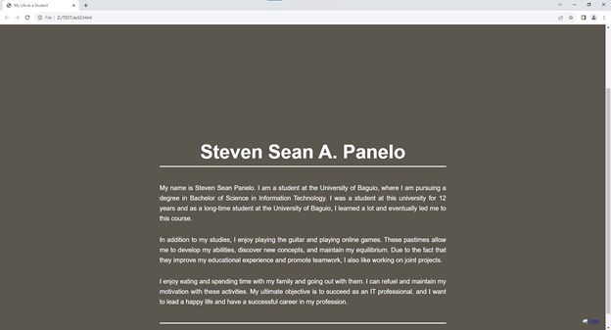

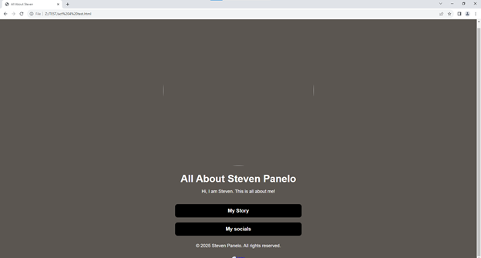

## 

## **50%**

**Date Accomplished**: 3/18/2025

**Code**: <!DOCTYPE html>

<html lang="en">

<head>

<meta charset="UTF-8">

<meta name="viewport" content="width=device-width, initial-scale=1.0">

<title>Thank You</title>

<style>

body {

background-color: #55504b;

margin: 0;

font-family: "Poppins", sans-serif;

text-align: center;

color: white;

display: flex;

flex-direction: column;

min-height: 100vh;

}

.thank-you-message {

flex-grow: 1;

display: flex;

flex-direction: column;

justify-content: center;

align-items: center;

}

.thank-you-message h2 {

font-size: 80px;

margin-bottom: 10px;

}

.thank-you-message p {

font-size: 20px;

margin-bottom: 20px;

}

.thank-you-message a {

display: inline-block;

padding: 10px 20px;

background: #000000;

color: white;

text-decoration: none;

border-radius: 5px;

font-weight: bold;

}

.thank-you-message a:hover {

background: #222;

}

footer {

text-align: center;

color: #F5F5F5;

padding: 20px 0;

}

.logo-container img {

width: 80px;

border-radius: 50%;

}

</style>

</head>

<body>

<div class="thank-you-message">

<h2>Thank You!</h2>

<p>Your details have been submitted successfully.</p>

<a href="act4.html">Go Back Home</a>

</div>

<footer>

<div class="logo-container">

<img src="Logo.png" alt="Logo">

</div>

<p>&copy; 2025 Steven Panelo. All rights reserved.</p>

</footer>

</body>

</html>

**Feedback**:

* At 50%, I added a contact us, without any direction or reason why I did it, just because it said that it was needed. My website was a wreck, that’s when I realized that I should changed it to something that a user can actually benefit from. That’s where I changed my design at 75%

**Picture**:

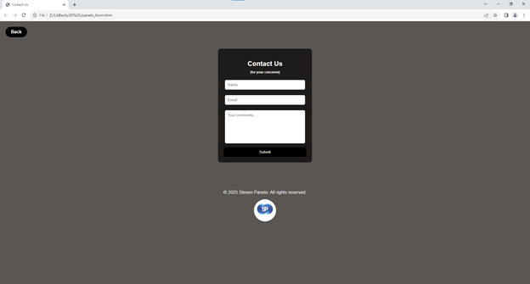

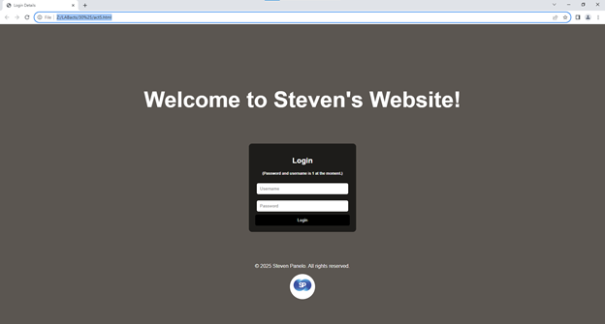

## 

## **75%**

**Date Accomplished**: 4/15/2025

**Code**: <!DOCTYPE html>

<html lang="en">

<head>

<meta charset="UTF-8">

<meta name="viewport" content="width=device-width, initial-scale=1.0">

<title>Welcome to Baguio City</title>

<link rel="stylesheet" href="Design.css">

</head>

<body>

<div class="navbar">

<div class="logo-container">

<img src="Logo.png" alt="Logo" class="logo">

<img src="breathe-baguio.png" alt="Baguio Logo" class="baguio-logo">

</div>

<div>

<a href="act4.html">Home</a>

<a href="act2.html">Tourist Spots</a>

<a href="act3.html">Foods</a>

<a href="panelo_form.html">Contact</a>

</div>

</div>

<div class="half-backgroundACT4">

<h1>Welcome to Baguio City</h1>

</div>

<div class="content-container">

<h2>History of Baguio</h2>

<div class="section">

<div class="text-container">

<p>Baguio City, known as the Summer Capital of the Philippines, has a rich and fascinating history. Originally home to the Ibaloi people, the area was transformed into a hill station by the Americans in the early 1900s due to its cool climate and picturesque landscape. The city’s layout was designed by the American architect Daniel Burnham, emphasizing green spaces, wide roads, and a structured urban plan.</p>

<p>During World War II, Baguio played a significant role and was occupied by Japanese forces. The city suffered heavy bombings towards the war's end but quickly recovered, evolving into a vital hub for tourism, education, and culture. Today, Baguio preserves its indigenous heritage while embracing modern developments, making it a dynamic and historically significant city in the Philippines.</p>

<p>The establishment of Baguio as a chartered city in 1909 marked a turning point in its development. It became a favored retreat for government officials and expatriates, leading to the construction of iconic landmarks such as Burnham Park and Camp John Hay. These historical sites remain integral to the city’s charm and attract visitors year-round.</p>

<p>Throughout the years, Baguio has become a center for education, housing several prestigious universities and institutions. The city's academic excellence, combined with its artistic heritage, fosters a culture of creativity and intellectual growth.</p>

</div>

<div>

<img src="old baguio.jpg" alt="Old Baguio City">

<p class="image-caption">Reference:

Google. (n.d.). Old people of Baguio City. Retrieved March 4, 2025,

from https://www.google.com/search?q=old+people+of+baguio+city</p>

</div>

</div>

<h2>The People of Baguio</h2>

<div class="section" style="flex-direction: row-reverse;">

<div class="text-container">

<p>The people of Baguio come from diverse cultural backgrounds, with a strong presence of the indigenous Ibaloi community, alongside migrants from various regions of the Philippines. This fusion of cultures has given the city a unique identity, where traditions and modern influences coexist harmoniously.</p>

<p>Despite the city’s growth and modernization, the people of Baguio remain deeply connected to their heritage. Indigenous practices, festivals, and arts continue to thrive, reflecting the city's rich history and strong sense of community. The annual Panagbenga Festival, for example, showcases the creativity and resilience of its people through elaborate floral floats and cultural performances.</p>

<p>Residents of Baguio are known for their hospitality and warmth, making visitors feel welcome in their city. The vibrant local markets, bustling cafés, and artistic hubs provide spaces where locals and tourists can engage, learn, and appreciate Baguio's dynamic culture.</p>

<p>Beyond its scenic views and cool climate, Baguio's heart lies in its people. Their resilience, adaptability, and creativity make the city not just a destination but a home filled with stories, traditions, and an enduring spirit of unity.</p>

</div>

<div>

<img src="old people.jpg" alt="People of Baguio">

<p class="image-caption">Reference:

Google. (n.d.). Old Baguio City. Retrieved March 4, 2025, from https://www.google.com/search?q=old+baguio+city</p>

</div>

</div>

<footer class="footer">

<p>&copy; 2025 Steven Panelo. All rights reserved.</p>

</footer>

</body>

</html>

Css:

body {

margin: 0;

font-family: "Poppins", sans-serif;

color: black;

overflow-x: hidden;

background-color: #f8f9fa;

}

.navbar {

display: flex;

justify-content: space-between;

align-items: center;

background-color: rgba(0, 50, 0, 0.8);

padding: 8px 5%;

width: 90%;

}

.logo-container {

display: flex;

align-items: center;

}

.logo {

width: 90px;

height: auto;

margin-right: 10px;

}

.baguio-logo {

width: 150px;

height: auto;

}

.navbar a {

color: white;

text-decoration: none;

font-size: 20px;

margin: 0 15px;

font-weight: bold;

}

.navbar a:hover {

text-decoration: underline;

}

.half-backgroundACT4 {

height: 45vh;

background: url('baguio.jpeg') no-repeat center center/cover;

display: flex;

align-items: center;

justify-content: center;

text-align: center;

position: relative;

}

.half-backgroundACT4 h1 {

font-size: 80px;

font-weight: bold;

text-transform: uppercase;

background: rgba(0, 50, 0, 0.5);

padding: 12px 20px;

border-radius: 10px;

color: white;

position: relative;

}

.content-container {

padding: 50px 10%;

text-align: center;

color: black;

}

.content-container h2 {

font-size: 50px;

font-weight: bold;

}

.section {

display: flex;

align-items: center;

justify-content: space-between;

margin-bottom: 50px;

}

.section img {

width: 80%;

height: 700px;

border-radius: 60px;

}

.image-caption {

font-size: 12px;

color: gray;

text-align: center;

margin-top: 5px;

}

.text-container {

width: 55%;

text-align: justify;

font-size: 20px;

line-height: 1.8;

}

.footer {

text-align: center;

background-color: rgba(0, 50, 0, 1);

padding: 10px 0;

font-size: 14px;

color: white;

}

.half-backgroundACT3 {

height: 45vh;

background: url(Strawberry.png) no-repeat center center/cover;

display: flex;

align-items: center;

justify-content: center;

text-align: center;

position: relative;

}

.half-backgroundACT3 h1 {

font-size: 60px;

font-weight: bold;

background: rgba(0, 50, 0, 0.7);

padding: 12px 20px;

border-radius: 10px;

color: white;

}

.food-item {

display: flex;

align-items: center;

justify-content: space-between;

margin-bottom: 50px;

}

.food-item img {

width: 50%;

height: auto;

border-radius: 20px;

}

.half-backgroundACT2 {

height: 45vh;

background: url('Country Club.jfif') no-repeat center center/cover;

display: flex;

align-items: center;

justify-content: center;

text-align: center;

position: relative;

}

.half-backgroundACT2 h1 {

font-size: 50px;

font-weight: bold;

background: rgba(0, 50, 0, 0.7);

padding: 12px 20px;

border-radius: 10px;

color: white;

}

.content-containerACT2 {

padding: 50px 5%;

display: flex;

flex-direction: column;

align-items: center;

gap: 50px;

}

.spot-container {

text-align: center;

width: 100%;

max-width: 600px;

}

.spot-title {

font-size: 22px;

font-weight: bold;

margin-bottom: 10px;

}

.spot {

position: relative;

width: 100%;

height: 350px;

overflow: hidden;

border-radius: 15px;

box-shadow: 0px 4px 10px rgba(0, 0, 0, 0.3);

cursor: pointer;

transition: transform 0.3s ease;

}

.spot:hover {

transform: scale(1.05);

}

.spot img {

width: 100%;

height: 100%;

object-fit: cover;

border-radius: 15px;

transition: transform 0.3s ease;

}

.spot:hover img {

transform: scale(1.1);

}

.spot .info {

position: absolute;

bottom: 0;

left: 0;

width: 100%;

height: 100%;

background: rgba(0, 50, 0, 0.9);

color: white;

display: flex;

flex-direction: column;

justify-content: center;

align-items: center;

padding: 20px;

opacity: 0;

transform: translateY(100%);

transition: transform 0.4s ease, opacity 0.4s ease;

}

.spot:hover .info {

opacity: 1;

transform: translateY(0);

}

.info h2 {

margin: 0;

font-size: 24px;

}

.info p {

font-size: 16px;

margin-top: 10px;

text-align: justify;

}

@media (max-width: 768px) {

.navbar {

flex-direction: column;

align-items: flex-start;

width: 100%;

}

.navbar a {

font-size: 18px;

margin: 10px 0;

}

.half-backgroundACT4 h1,

.half-backgroundACT3 h1,

.half-backgroundACT2 h1 {

font-size: 40px;

padding: 10px 15px;

}

.content-container h2 {

font-size: 32px;

}

.section,

.food-item {

flex-direction: column;

text-align: center;

}

.section img,

.food-item img {

width: 100%;

height: auto;

border-radius: 20px;

}

.text-container {

width: 100%;

font-size: 18px;

}

.spot-container {

max-width: 90%;

}

.spot {

height: 250px;

}

.info h2 {

font-size: 20px;

}

.info p {

font-size: 14px;

}

footer {

font-size: 12px;

}

.logo-container img {

width: 60px;

}

}

@media (max-width: 480px) {

.half-backgroundACT4 h1,

.half-backgroundACT3 h1,

.half-backgroundACT2 h1 {

font-size: 30px;

}

.content-container {

padding: 30px 5%;

}

.content-container h2 {

font-size: 26px;

}

.text-container {

font-size: 16px;

line-height: 1.5;

}

.spot {

height: 200px;

}

.info h2 {

font-size: 18px;

}

.info p {

font-size: 12px;

}

}

**Feedback**:

* My website now at 75% is about Baguio City. This includes the home page of course, the tourist spots, foods, and a contact that I am still finishing for the 100%, I also plan to add a carousel at the home page. I also indicated which part is the css and the html so that the design will be consistent.

**Picture**:

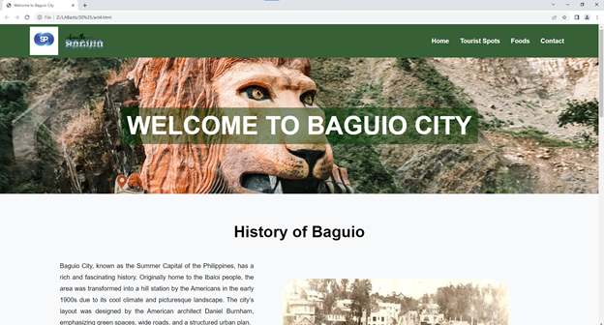

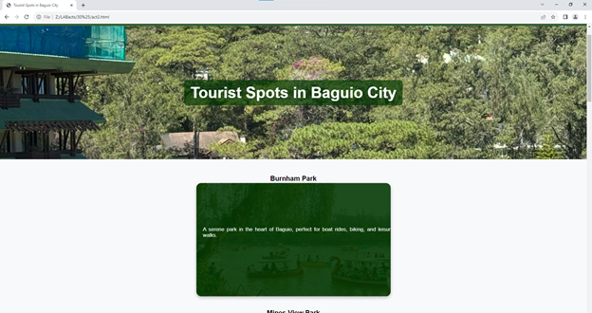

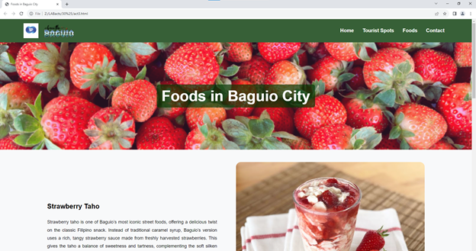

## 

## 

## **90%**

**Date Accomplished**: 4/29/2025

**Code**: <!DOCTYPE html>

<html lang="en">

<head>

<meta charset="UTF-8">

<meta name="viewport" content="width=device-width, initial-scale=1.0">

<title>Welcome to Baguio City</title>

<link rel="stylesheet" href="Design.css">

</head>

<body>

<div class="navbar">

<div class="logo-container">

<img src="Logo.png" alt="Logo" class="logo">

<img src="breathe-baguio.png" alt="Baguio Logo" class="baguio-logo">

</div>

<div>

<a href="act4.html">Home</a>

<a href="act2.html">Tourist Spots</a>

<a href="act3.html">Foods</a>

<a href="panelo_form.html">Contact</a>

</div>

</div>

<div class="half-backgroundACT4">

<h1>Welcome to Baguio City</h1>

</div>

<div class="content-container">

<h2>History of Baguio</h2>

<div class="section">

<div class="text-container">

<p>Baguio City, known as the Summer Capital of the Philippines, has a rich and fascinating history. Originally home to the Ibaloi people, the area was transformed into a hill station by the Americans in the early 1900s due to its cool climate and picturesque landscape. The city’s layout was designed by the American architect Daniel Burnham, emphasizing green spaces, wide roads, and a structured urban plan.</p>

<p>During World War II, Baguio played a significant role and was occupied by Japanese forces. The city suffered heavy bombings towards the war's end but quickly recovered, evolving into a vital hub for tourism, education, and culture. Today, Baguio preserves its indigenous heritage while embracing modern developments, making it a dynamic and historically significant city in the Philippines.</p>

<p>The establishment of Baguio as a chartered city in 1909 marked a turning point in its development. It became a favored retreat for government officials and expatriates, leading to the construction of iconic landmarks such as Burnham Park and Camp John Hay. These historical sites remain integral to the city’s charm and attract visitors year-round.</p>

<p>Throughout the years, Baguio has become a center for education, housing several prestigious universities and institutions. The city's academic excellence, combined with its artistic heritage, fosters a culture of creativity and intellectual growth.</p>

</div>

<div>

<img src="old baguio.jpg" alt="Old Baguio City">

<p class="image-caption">Reference:

Google. (n.d.). Old people of Baguio City. Retrieved March 4, 2025,

from https://www.google.com/search?q=old+people+of+baguio+city</p>

</div>

</div>

<h2>The People of Baguio</h2>

<div class="section" style="flex-direction: row-reverse;">

<div class="text-container">

<p>The people of Baguio come from diverse cultural backgrounds, with a strong presence of the indigenous Ibaloi community, alongside migrants from various regions of the Philippines. This fusion of cultures has given the city a unique identity, where traditions and modern influences coexist harmoniously.</p>

<p>Despite the city’s growth and modernization, the people of Baguio remain deeply connected to their heritage. Indigenous practices, festivals, and arts continue to thrive, reflecting the city's rich history and strong sense of community. The annual Panagbenga Festival, for example, showcases the creativity and resilience of its people through elaborate floral floats and cultural performances.</p>

<p>Residents of Baguio are known for their hospitality and warmth, making visitors feel welcome in their city. The vibrant local markets, bustling cafés, and artistic hubs provide spaces where locals and tourists can engage, learn, and appreciate Baguio's dynamic culture.</p>

<p>Beyond its scenic views and cool climate, Baguio's heart lies in its people. Their resilience, adaptability, and creativity make the city not just a destination but a home filled with stories, traditions, and an enduring spirit of unity.</p>

</div>

<div>

<img src="old people.jpg" alt="People of Baguio">

<p class="image-caption">Reference:

Google. (n.d.). Old Baguio City. Retrieved March 4, 2025, from https://www.google.com/search?q=old+baguio+city</p>

</div>

</div>

</div>

<!-- Events Carousel Section -->

<div class="events-carousel-container">

<h2>Events in Baguio City</h2>

<div class="events-carousel">

<div class="carousel-track">

<div class="event-card">

<img src="Baguio New Year.jpg" alt="Panagbenga Festival">

<div class="event-info">

<h3>January - Chinese New Year</h3>

<p>A vibrant celebration with dragon dances and fireworks.</p>

</div>

</div>

<div class="event-card">

<img src="February.jpg" alt="Chinese New Year">

<div class="event-info">

<h3>February - Panagbenga Festival</h3>

<p>The annual flower festival featuring grand floats and street dancing.</p>

</div>

</div>

<div class="event-card">

<img src="March.jpg" alt="Strawberry Festival">

<div class="event-info">

<h3>March - Strawberry Festival</h3>

<p>A month-long celebration in La Trinidad, near Baguio.</p>

</div>

</div>

<div class="event-card">

<img src="April.jpg" alt="Holy Week Observance">

<div class="event-info">

<h3>April - Holy Week Observance</h3>

<p>Religious processions and cultural traditions in the city.</p>

</div>

</div>

<div class="event-card">

<img src="May.jpg" alt="Baguio Summer Vacation">

<div class="event-info">

<h3>May - Baguio Summer Vacation</h3>

<p>Tourists flock to Baguio to escape the summer heat.</p>

</div>

</div>

<div class="event-card">

<img src="June.jpg" alt="Independence Day">

<div class="event-info">

<h3>June - Independence Day</h3>

<p>A patriotic celebration with flag-raising and parades.</p>

</div>

</div>

<div class="event-card">

<img src="July.jpg" alt="Cordillera Day">

<div class="event-info">

<h3>July - Cordillera Day</h3>

<p>A festival honoring Cordilleran heritage and traditions.</p>

</div>

</div>

<div class="event-card">

<img src="August.jpg" alt="Baguio Day Preparation">

<div class="event-info">

<h3>August - Baguio Day Preparation</h3>

<p>Preparations for Baguio City's foundation day.</p>

</div>

</div>

<div class="event-card">

<img src="September.jpg" alt="Baguio Day Celebration">

<div class="event-info">

<h3>September - Baguio Day Celebration</h3>

<p>Baguio City's foundation day with parades and events.</p>

</div>

</div>

<div class="event-card">

<img src="October.jpg" alt="Halloween Events">

<div class="event-info">

<h3>October - Halloween Events</h3>

<p>Spooky celebrations and haunted tours.</p>

</div>

</div>

<div class="event-card">

<img src="November.jpg" alt="Undas">

<div class="event-info">

<h3>November - Undas</h3>

<p>All Saints' Day and All Souls' Day remembrance.</p>

</div>

</div>

<div class="event-card">

<img src="December.jpg" alt="Christmas in Baguio">

<div class="event-info">

<h3>December - Christmas in Baguio</h3>

<p>Festive decorations, parades, and holiday markets.</p>

</div>

</div>

</div>

<button class="carousel-prev">&#10094;</button>

<button class="carousel-next">&#10095;</button>

</div>

</div>

<style>

.events-carousel-container {

text-align: center;

padding: 50px 5%;

background: #1a1a1a;

color: white;

}

.events-carousel h2 {

font-size: 36px;

margin-bottom: 20px;

}

.events-carousel {

position: relative;

max-width: 90%;

margin: auto;

overflow: hidden;

}

.carousel-track {

display: flex;

gap: 20px;

transition: transform 0.5s ease-in-out;

width: 100%;

}

.event-card {

min-width: 300px;

background: #222;

border-radius: 15px;

overflow: hidden;

text-align: center;

box-shadow: 0 5px 15px rgba(0, 255, 255, 0.3);

}

.event-card img {

width: 100%;

height: 200px;

object-fit: cover;

border-bottom: 3px solid cyan;

}

.event-info {

padding: 15px;

}

.event-info h3 {

font-size: 22px;

color: cyan;

margin-bottom: 10px;

}

.event-info p {

font-size: 16px;

opacity: 0.8;

}

.carousel-prev, .carousel-next {

position: absolute;

top: 50%;

transform: translateY(-50%);

background: rgba(0, 255, 255, 0.7);

color: black;

border: none;

padding: 10px 15px;

font-size: 20px;

cursor: pointer;

border-radius: 50%;

}

.carousel-prev {

left: 0;

}

.carousel-next {

right: 0;

}

.carousel-prev:hover, .carousel-next:hover {

background: cyan;

}

</style>

<script>

document.addEventListener("DOMContentLoaded", function() {

const track = document.querySelector(".carousel-track");

const prev = document.querySelector(".carousel-prev");

const next = document.querySelector(".carousel-next");

let index = 0;

next.addEventListener("click", function() {

if (index < 9) {

index++;

track.style.transform = `translateX(-${index * 320}px)`;

}

});

prev.addEventListener("click", function() {

if (index > 0) {

index--;

track.style.transform = `translateX(-${index * 320}px)`;

}

});

});

</script>

<footer class="footer">

<p>&copy; 2025 Steven Panelo. All rights reserved.</p>

</footer>

</body>

</html>

**Feedback**:

· I decided that for my 100%, I will furnish everything and add the contact us page. So for 90%, I added a carousel css at the home page to indicate the events that will happen each month in Baguio.

· I also added a section on the css where it can now be responsive whether in phone and the computer itself.

**Picture**:

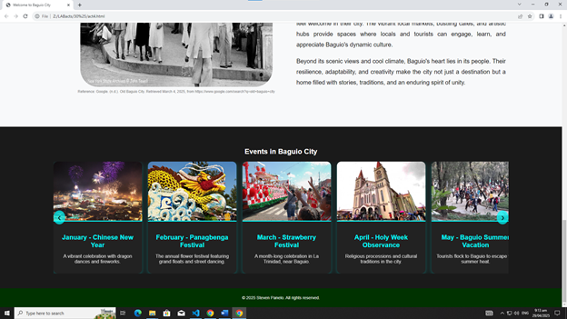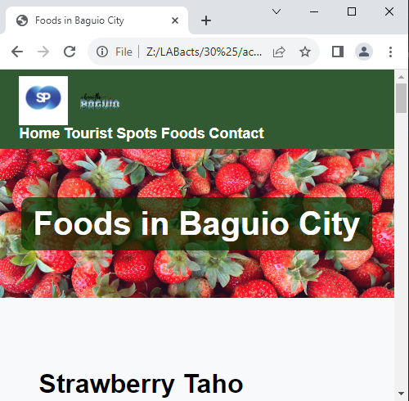

## **100%**

**Date Accomplished: 6/5/2025**

**Code:**

**<!DOCTYPE html>**

**<html lang="en">**

**<head>**

**<meta charset="UTF-8">**

**<meta name="viewport" content="width=device-width, initial-scale=1.0">**

**<title>Welcome to Baguio City</title>**

**<link rel="stylesheet" href="CSS/Design.css">**

**</head>**

**<body>**

**<div class="navbar">**

**<div class="logo-container">**

**<img src="IMAGES/Logo.png" alt="Logo" class="logo">**

**<img src="IMAGES/breathe-baguio.png" alt="Baguio Logo" class="baguio-logo">**

**</div>**

**<div>**

**<a href="act4.html">Home</a>**

**<a href="act2.html">Tourist Spots</a>**

**<a href="act3.html">Foods</a>**

**<a href="panelo_form.html">Contact</a>**

**</div>**

**</div>**

**<div class="half-backgroundACT4">**

**<h1>Welcome to Baguio City</h1>**

**</div>**

**<div class="content-container">**

**<h2>History of Baguio</h2>**

**<div class="section">**

**<div class="text-container">**

**<p>Baguio City, known as the Summer Capital of the Philippines, has a rich and fascinating history. Originally home to the Ibaloi people, the area was transformed into a hill station by the Americans in the early 1900s due to its cool climate and picturesque landscape. The city’s layout was designed by the American architect Daniel Burnham, emphasizing green spaces, wide roads, and a structured urban plan.</p>**

**<p>During World War II, Baguio played a significant role and was occupied by Japanese forces. The city suffered heavy bombings towards the war's end but quickly recovered, evolving into a vital hub for tourism, education, and culture. Today, Baguio preserves its indigenous heritage while embracing modern developments, making it a dynamic and historically significant city in the Philippines.</p>**

**<p>The establishment of Baguio as a chartered city in 1909 marked a turning point in its development. It became a favored retreat for government officials and expatriates, leading to the construction of iconic landmarks such as Burnham Park and Camp John Hay. These historical sites remain integral to the city’s charm and attract visitors year-round.</p>**

**<p>Throughout the years, Baguio has become a center for education, housing several prestigious universities and institutions. The city's academic excellence, combined with its artistic heritage, fosters a culture of creativity and intellectual growth.</p>**

**</div>**

**<div>**

**<img src="IMAGES/old baguio.jpg" alt="Old Baguio City">**

**<p class="image-caption">Reference:**

**Google. (n.d.). Old people of Baguio City. Retrieved March 4, 2025,**

**from https://www.google.com/search?q=old+people+of+baguio+city</p>**

**</div>**

**</div>**

**<h2>The People of Baguio</h2>**

**<div class="section" style="flex-direction: row-reverse;">**

**<div class="text-container">**

**<p>The people of Baguio come from diverse cultural backgrounds, with a strong presence of the indigenous Ibaloi community, alongside migrants from various regions of the Philippines. This fusion of cultures has given the city a unique identity, where traditions and modern influences coexist harmoniously.</p>**

**<p>Despite the city’s growth and modernization, the people of Baguio remain deeply connected to their heritage. Indigenous practices, festivals, and arts continue to thrive, reflecting the city's rich history and strong sense of community. The annual Panagbenga Festival, for example, showcases the creativity and resilience of its people through elaborate floral floats and cultural performances.</p>**

**<p>Residents of Baguio are known for their hospitality and warmth, making visitors feel welcome in their city. The vibrant local markets, bustling cafés, and artistic hubs provide spaces where locals and tourists can engage, learn, and appreciate Baguio's dynamic culture.</p>**

**<p>Beyond its scenic views and cool climate, Baguio's heart lies in its people. Their resilience, adaptability, and creativity make the city not just a destination but a home filled with stories, traditions, and an enduring spirit of unity.</p>**

**</div>**

**<div>**

**<img src="IMAGES/old people.jpg" alt="People of Baguio">**

**<p class="image-caption">Reference:**

**Google. (n.d.). Old Baguio City. Retrieved March 4, 2025, from https://www.google.com/search?q=old+baguio+city</p>**

**</div>**

**</div>**

**</div>**

**<!-- Events Carousel Section -->**

**<div class="events-carousel-container">**

**<h2>Events in Baguio City</h2>**

**<div class="events-carousel">**

**<div class="carousel-track">**

**<div class="event-card">**

**<img src="IMAGES/Baguio New Year.jpg" alt="Panagbenga Festival">**

**<div class="event-info">**

**<h3>January - Chinese New Year</h3>**

**<p>A vibrant celebration with dragon dances and fireworks.</p>**

**</div>**

**</div>**

**<div class="event-card">**

**<img src="IMAGES/February.jpg" alt="Chinese New Year">**

**<div class="event-info">**

**<h3>February - Panagbenga Festival</h3>**

**<p>The annual flower festival featuring grand floats and street dancing.</p>**

**</div>**

**</div>**

**<div class="event-card">**

**<img src="IMAGES/March.jpg" alt="Strawberry Festival">**

**<div class="event-info">**

**<h3>March - Strawberry Festival</h3>**

**<p>A month-long celebration in La Trinidad, near Baguio.</p>**

**</div>**

**</div>**

**<div class="event-card">**

**<img src="IMAGES/April.jpg" alt="Holy Week Observance">**

**<div class="event-info">**

**<h3>April - Holy Week Observance</h3>**

**<p>Religious processions and cultural traditions in the city.</p>**

**</div>**

**</div>**

**<div class="event-card">**

**<img src="IMAGES/May.jpg" alt="Baguio Summer Vacation">**

**<div class="event-info">**

**<h3>May - Baguio Summer Vacation</h3>**

**<p>Tourists flock to Baguio to escape the summer heat.</p>**

**</div>**

**</div>**

**<div class="event-card">**

**<img src="IMAGES/June.jpg" alt="Independence Day">**

**<div class="event-info">**

**<h3>June - Independence Day</h3>**

**<p>A patriotic celebration with flag-raising and parades.</p>**

**</div>**

**</div>**

**<div class="event-card">**

**<img src="IMAGES/July.jpg" alt="Cordillera Day">**

**<div class="event-info">**

**<h3>July - Cordillera Day</h3>**

**<p>A festival honoring Cordilleran heritage and traditions.</p>**

**</div>**

**</div>**

**<div class="event-card">**

**<img src="IMAGES/August.jpg" alt="Baguio Day Preparation">**

**<div class="event-info">**

**<h3>August - Baguio Day Preparation</h3>**

**<p>Preparations for Baguio City's foundation day.</p>**

**</div>**

**</div>**

**<div class="event-card">**

**<img src="IMAGES/September.jpg" alt="Baguio Day Celebration">**

**<div class="event-info">**

**<h3>September - Baguio Day Celebration</h3>**

**<p>Baguio City's foundation day with parades and events.</p>**

**</div>**

**</div>**

**<div class="event-card">**

**<img src="IMAGES/October.jpg" alt="Halloween Events">**

**<div class="event-info">**

**<h3>October - Halloween Events</h3>**

**<p>Spooky celebrations and haunted tours.</p>**

**</div>**

**</div>**

**<div class="event-card">**

**<img src="IMAGES/November.jpg" alt="Undas">**

**<div class="event-info">**

**<h3>November - Undas</h3>**

**<p>All Saints' Day and All Souls' Day remembrance.</p>**

**</div>**

**</div>**

**<div class="event-card">**

**<img src="../IMAGES/December.jpg" alt="Christmas in Baguio">**

**<div class="event-info">**

**<h3>December - Christmas in Baguio</h3>**

**<p>Festive decorations, parades, and holiday markets.</p>**

**</div>**

**</div>**

**</div>**

**<button class="carousel-prev">&#10094;</button>**

**<button class="carousel-next">&#10095;</button>**

**</div>**

**</div>**

**<style>**

**.events-carousel-container {**

**text-align: center;**

**padding: 50px 5%;**

**background: #1a1a1a;**

**color: white;**

**}**

**.events-carousel h2 {**

**font-size: 36px;**

**margin-bottom: 20px;**

**}**

**.events-carousel {**

**position: relative;**

**max-width: 90%;**

**margin: auto;**

**overflow: hidden;**

**}**

**.carousel-track {**

**display: flex;**

**gap: 20px;**

**transition: transform 0.5s ease-in-out;**

**width: 100%;**

**}**

**.event-card {**

**min-width: 300px;**

**background: #222;**

**border-radius: 15px;**

**overflow: hidden;**

**text-align: center;**

**box-shadow: 0 5px 15px rgba(0, 255, 255, 0.3);**

**}**

**.event-card img {**

**width: 100%;**

**height: 200px;**

**object-fit: cover;**

**border-bottom: 3px solid cyan;**

**}**

**.event-info {**

**padding: 15px;**

**}**

**.event-info h3 {**

**font-size: 22px;**

**color: cyan;**

**margin-bottom: 10px;**

**}**

**.event-info p {**

**font-size: 16px;**

**opacity: 0.8;**

**}**

**.carousel-prev, .carousel-next {**

**position: absolute;**

**top: 50%;**

**transform: translateY(-50%);**

**background: rgba(0, 255, 255, 0.7);**

**color: black;**

**border: none;**

**padding: 10px 15px;**

**font-size: 20px;**

**cursor: pointer;**

**border-radius: 50%;**

**}**

**.carousel-prev {**

**left: 0;**

**}**

**.carousel-next {**

**right: 0;**

**}**

**.carousel-prev:hover, .carousel-next:hover {**

**background: cyan;**

**}**

**</style>**

**<footer class="footer">**

**<p>&copy; 2025 Steven Panelo. All rights reserved.</p>**

**</footer>**

**<script src="../30%/JS/website java script.js"></script>**

**</body>**

**</html>**

**Feedback:** Ma’am said to add javascript and separate it and also to follow the navbar and footer whenever the user scrolls. I also fixed the contact form. It is now complete

**Picture:**

